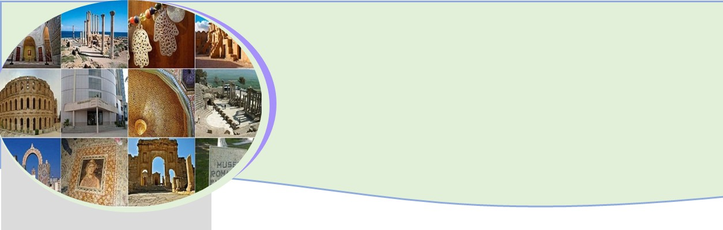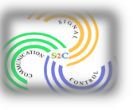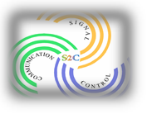2nd International Conference on
Signal, Control and Communication
SCC 2021

December 20-22, 2021 Tunisia

Call for papers: Invited Session

Session Chairs
1-Name, Title and Affiliation of Chair
2-
3-

Session title

max 10 words

Session outline

A statement of justification – why is this session relevant in the SCC 2021?
max 100 words

Session description

Session full description: aims, scope (300 words) List of main topics

Main Contributing Researchers

Titles, authors with affiliations and abstracts of all contributions.

https://scc.ieee.tn/ conf.scc2021@gmail.com

2nd International Conference on
Signal, Control and Communication
SCC 2021

https://scc.ieee.tn/ conf.scc2021@gmail.com

